- Brainstorming
- Singleplayer Multitouch Table Dice
  - First Iteration
  - Second Iteration
- Two-Player Multitouch Table Dice
  - Third Iteration
  - Fourth Iteration
- Star Dice
  - Fifth Iteration
  - Sixth Iteration
  - Seventh Iteration
  - Eighth Iteration
- Cost Analysis
- Final Rules
  - Introduction
  - Materials Included
  - One-Time Installation
  - Running Star Dice
  - Rules of Play

Brainstorming
Objectives to prompt brainstorming:
- Create a more involved battle system for a war game, a la Axis & Allies.
- Combine dice with the game jam.
- Take advantage of physical properties of dice.
- Make a dice game that isn't about numbers.
Brainstorm: How to create a more involved battle system for a war game, a la Axis & Allies:
- Spaceships for units.
- Could use ship types from Twilight Imperium.
- Sea ships for units.
- Sizes of rolled dice have an effect on the battle, not just the numbers that they roll.
- Sizes multiply damage.
- Sizes are different types of weapons. (lasers, torpedoes, etc...)
- Die size indicates the kind of ship that it damages.
- Die size indicates ship size. Affects priority order of damaging ships.
- Different units can combine attacks.
- Dice are the units themselves.
- Number used to indicate hit points of unit.
- But is this really a dice game?
- Each unit rolls its die, number rolled is attack value.
- Type of unit/die indicates type of damage.
- Or priority for matching against enemy unit.
- Number rolled indicates some special ability activated by the unit.
- Players take bets on results of battle.
- Players can load resources onto transports of whichever player they feel the most confident about.
Brainstorm: How to combine dice with the game jam:
- Networked video game where players roll real dice.
- How to integrate real dice into game? Players may cheat.
- A game about trust.
- Use camera to detect dice.
- Players roll dice on multitouch table. Can detect where dice land.
- Throw dice from a distance.
- Drop dice.
- Different dice will drop differently. Conveniently, the d4 bounces the least but is also worth the least.
- Players take turns rolling dice onto table.
- Dice near each other get bonuses.
- Draw lines between dice to create shapes.
- Rolled number gives points, but shapes give point multipliers.
- Can knock other player's dice out of shapes.
- Can drop dice into shapes for extra bonuses.
- Since we have video projection, can add a lot of visual flair not normally available in pure dice games.
- Cool video in background.
- Use shaders to alter colors of background near dice.
- Use red/blue colors to indicate whose turn it is.
- Retro style graphics.
- Track which dice are the farthest down the table.
- A marbles-type game.
- Dice can land on virtual areas which have special effects.
- Point multipliers.
- Lose a turn.
- Extra turn.
- Remove an opponent's die.
- Lose your own die.
- Allow access to larger dice.
- Roll dice on motion floor.
- One player rolls dice, the other can move the floor to affect results.
- Tape of sections of floor -- where die lands affects the outcome of the game.
- Different sections are worth different multipliers.
- Some sections cause certain motions, potentially dislodging other dice.
- Enter results of rolled dice into computer, which then does some sort of calculation that couldn't be done by hand.
- How is this more compelling than without a computer?
- Some sort of chaos theory / butterfly effect kind of thing.
Brainstorm: How to take advantage of physical properties of dice:
- Stack them in towers.
- How high can they be stacked?
- Once tower finally falls, sum results and that's your score.
- Marbles but with dice?
- Only dice in circle contribute to score.
- Throw dice at people!
- How does the value rolled affect the game?
- Each person has a number of hit points. If the die hits, it does that much damage.
Brainstorm: How to make a dice game that isn't about numbers:
- Use blank dice and draw symbols on the sides.
- Charades.
- Use dice to combine nouns/adjectives/verbs.
- Use dice to pick beginning/middle/end of a story that must then be acted out.
- Players use dry-erase markers to add symbols to dice as the game progresses.
- Could also add numbers, even though that's not the initial objective of this brainstorm.
- Like H.O.R.S.E., but players add actions to die.
- What actions? What sport?
- Basketball!
- Gymnastics.
- Exercises (jumping jacks, push-ups, etc...)
- Dice tell player several things to do at the same time, such as hop while rubbing tummy while singing.
- Players make up rules and add them to sides of dice. Kind of like Calvinball.
Brainstorming reflection:
I definitely feel most inspired by the multitouch table dice game, and not just because it's a way to combine this dice game assignment with the game jam. It strikes me as a wholly unique interaction and new kind of platform. Also, I came up with the most game ideas for that platform, and they all excite me. I think my favorite of those ideas is the one where dropped dice generate shapes that award bonuses. It seems the most organic and the one with the most emergent gameplay.
The whole general goal of creating a war game battle system doesn't really inspire me. I think I have some interesting ideas here that could be interesting within an actual war game, but they don't seem to lend themselves to creating a dice game. That being said, I do like the idea of taking bets on the outcome of a battle.
While I like the general idea of taking advantage of the physical properties of dice (like the spinning dice game Jesse described), none of these ideas strike me as particularly great. Throwing dice at people sounds fun, but it's likely to be impractical. Stacking the dice into towers is probably my favorite idea for that objective, but ultimately it doesn't sound very deep.
I'm definitely intrigued by a dice game without numbers, especially one in which the players add rules of actions to the sides of dice. I can see there being a lot of emergent gameplay with those kinds of games. The particular ideas about combining actions as instructed by the rolls of dice strike me as probably either too easy or too hard.
Ultimately, I feel the most inspired and the most confident about the multitouch table dice game. I'll start by prototyping my favorite idea (dice create shapes), and then iterating from there unless it proves unworkable, in which case I'll try one of the other multitouch table ideas.
Process going forward:
I am going to prototype two variants of the multitouch table dice game with dice connecting to make shapes.
The first will be a single-player variant. This will enable me to get the technology working and work out kinks in the software. It will allow me to playtest some interactions that will apply to my second variant as well.
The second will be a multiplayer variant, which will build off the single-player variant.
With the multitouch table I have the ability to add visual and acoustic feedback to make the game more fun and juicy. However, I will add these near the end of the playtesting process so that I can concentrate on getting the pure gameplay working.

Singleplayer Multitouch Table Dice

First Iteration
Intended audience:
- People who like cool new technology.
- People who like games with a little bit about strategy.
- People who like games requiring a little bit of physical skill.
Materials:
- 1 multitouch table, about 12" by 9".
- 1 of each of the common die sizes: 1d4, 1d6, 1d8, 1d10, 1d12, 1d20
Setup:
- Start the multitouch table. Remove any dice or other objects from the table.
- Hold all six dice in your hand or in your pocket.
Rules of play:
- Choose one of your dice-in-hand and roll it onto the table.
  - If the die lands within the table, it will be recognized by the software and marked with a circle.
  - If the die does not land within the table, you may pick it back up and re-throw it.
- Choose another one of your dice-in-hand and roll it also onto the table.
  - If the die lands within the table, it will be recognized by the software and marked with a circle.
    - If the die lands near another die already on the table, the software will draw a connection to that die unless it already has two connections of its own.
  - If the die does not land within the table, you may pick it back up and re-throw it.
  - It is perfectly okay to knock dice around. This is part of the strategy.
- Repeat step 2 until you are out of dice-in-hand.
- Calculate your score using the following rules:
  - Any single dice or dice that are not part of a closed shape composed of 3 or more total dice are worth their rolled face values.
  - Any dice that are part of a closed shape composed of 3 total dice are worth twice their rolled face values. For each additional die composing the shape, increase the multiplier by 1. For example, a 4-die shape would triple the values of the dice in that shape, and a 5-die shape would quadruple the values of the dice in that shape.
Objective: Achieve the highest score possible at the end of the match.
Software design:
The software must:
- Visually recognize the position of dice on the table by drawing a circle around each die.
- Visually connect dice that are "close enough" to each other, except for dice that already have two connections.
  - For testing purposes, let's start with "close enough" being about a quarter of the screen.
- Respond to changes in dice positions as they occur.
Playtest:
Sat. Jan. 30, 2010, 1:15pm
Walt Destler (me)
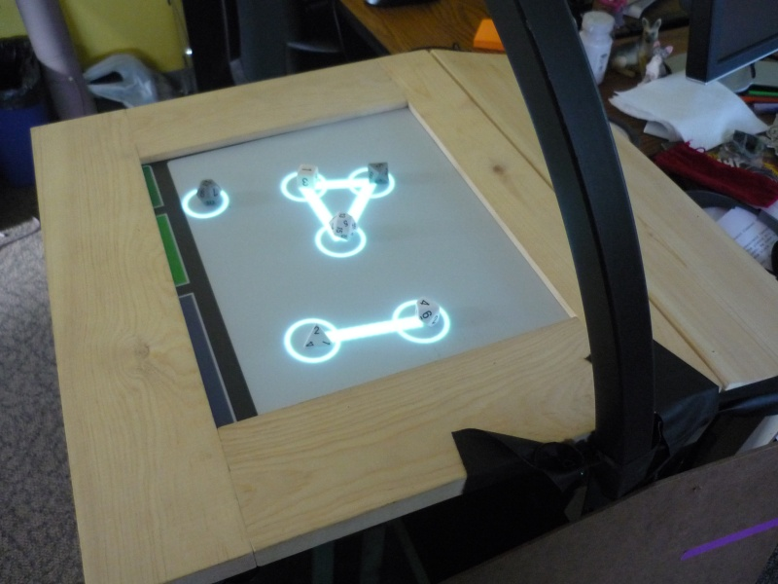
Questions to answer by playtesting (and answers discovered after playtesting):
- If the "close enough" distance for connecting dice too low, too high, or right on?
  - Seems about right. Maybe a tad low, but I'll leave it the same for now.
- Is the number of dice given to the player at the beginning too few, too many, or right on?
  - Again, seems about right.
- How do the different value ranges of the dice affect strategy?
  - The objective wasn't concrete enough (see "what didn't work" below), so I didn't really pay much attention to the actual values rolled. However, I did find myself thinking about trying to get the biggest dice into shapes. I would sometimes try to knock a lower-sided die away from a shape and replace it with a higher-sided die.
- Do the physical properties of the dice affect strategy?
  - Not quite as much as I was hoping, but still a little. The smaller dice position more predictably than the larger dice, which is a nice trade-off.
- How does the general difficulty feel?
  - About right. Definitely not too easy, but I always felt like I had a chance of pulling a move off.
- Does the balance between strategy, skill, and chance feel good?
  - Again, about right, though there's maybe too much chance involved. I wish that the die positions were a little more predictable and a little less up to blind luck. But skill will probably improve this.
What worked:
- Trying to get dice to connect into closed shapes is pretty challenging and pretty engaging.
- The software and multitouch technology essentially work surprisingly well, it a tad bit finicky.
What didn't work (and possible solution ideas):
- There's a bug in the software that allows dice to make more than two connections.
  - Should be an easy bug fix.
- It can be hard to tell whether dice are part of an open or closed shape if they are too close together.
  - I will color the closed shapes differently from the open shapes.
- It can be hard to tell which shape a die is a part of.
  - I will color the shapes differently from each other.
- The start of the game seems really open, not enough strategy yet.
  - Start with some sort of die already on the table? Perhaps a die worth zero? Maybe it is dropped from overhead.
- The objective isn't very compelling. Need a more concrete goal. I didn't even bothering summing my results most of the time.
  - Start with a set of "objective dice" already on the table. Their score is the score to beat.
  - Computer-assigned objectives.
  - Keep trying for an ever-increasing score until failure. Maybe 10 points per iteration?
    - Allow jumping to higher levels with enough points.
- Dice that are just barely close enough to make a connection tend to flicker between connected and not connected.
  - Will fix in software.
- No difference between connected (but not closed) dice and single dice. It feels like connecting dice should get you something.
  - Single dice worth nothing, while connected dice worth face values.
  - Single dice worth 1, while connected dice worth face values.
Questions that need answering (and possible answers):
- What's to prevent the player from simply placing a die where he wants it? What does it mean to "roll" the die? How close can he get to the table? Can the dice be dropped from overhead?
  - Die must hit frame of table before rolling onto touch surface.
- What happens if the player accidentally occludes the IR with his hand? Is that a foul? If so, what is the penalty?
  - Lose a die-in-hand.
- Sometimes a die isn't detected by the software, particularly when they're near the edges. Are these dice counted?
  - They count as single, unconnected dice.
- Sometimes dice are close together and identified as a single die by the software. How are these dice counted?
  - Their values are summed and then both are treated as a single die for the purposes of shapes.
Playtest reflections:
Overall, things worked surprisingly well. Definitely need a better objective -- something to drive the game forward and provide a more concrete goal. Lots of issues to fix, but the fixes should generally be pretty straightforward. I'm really quite pleased though. For a first playtest, things worked quite well and parts were actually fun.
Process going forward:
Will make all of the above fixes and rules changes. I will playtest two different rules versions to try out a couple different new objectives. I'm not sure which will work better, so I want to test both.

Second Iteration
For this second iteration, I am testing two different objectives, each of which requires changes to various rules. Such changes that only apply to one objective are prepended with (Objective 1) or (Objective 2).
Changes to intended audience: None
Changes to materials:
- (Objective 1) An additional blank d6.
- (Objective 2) A set of red dice matching the player's set of white dice.
Changes to setup:
- (Objective 1) Drop the blank d6 from directly over the table onto the table.
- (Objective 2) Roll all the red dice at once onto the table.
Changes to rules of play:
- (Objective 1) The blank d6 is treated as a die that is always worth 0. (But it still counts for making shapes.)
- (Objective 2) The white and red dice may mix within the same shape.
- (Objective 2) After calculating the score of your own white dice, calculate the score of the red dice in exactly the same manner.
- Single dice are worth 1 each, while connected dice not in a closed shape are worth their face values.
- In the event that a die on the touch surface is not detected by the software, it is treated as a single unconnected die.
- In the event that two or more dice are so close together that they are detected as a single die, then they are treated as a single die whose value is their sum.
- When rolling a die, the die must touch at least once the table frame before rolling onto the touch surface. Failure to do so as a foul.
- Accidentally occluding the IR emitters thus resetting the software is a foul.
- Fouls: When a play incurs a foul, he must immediately discard one die of his choice from his hand. If he has no dice left, then he automatically loses the game.
Changes to objective:
- (Objective 1) Play a number of rounds. First round you need to beat 10 points. Second round 20 points, third round 30 points, and so on. See you far you can get before failing.
- (Objective 2) You win if your total score exceeds the total score of the red dice.
Changes to software design:
- Fix bug occasionally allowing for more than two connections.
- Fix issue where connections can flicker on/off between dice that are almost too far apart.
- Open shapes should be colored white, closed shapes should be colored and different from each other.
Playtest:
Sat. Jan. 30, 2010, 3:51pm
Walt Destler (me)
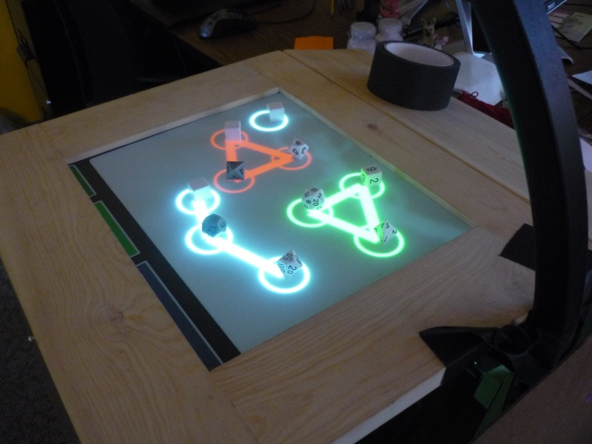
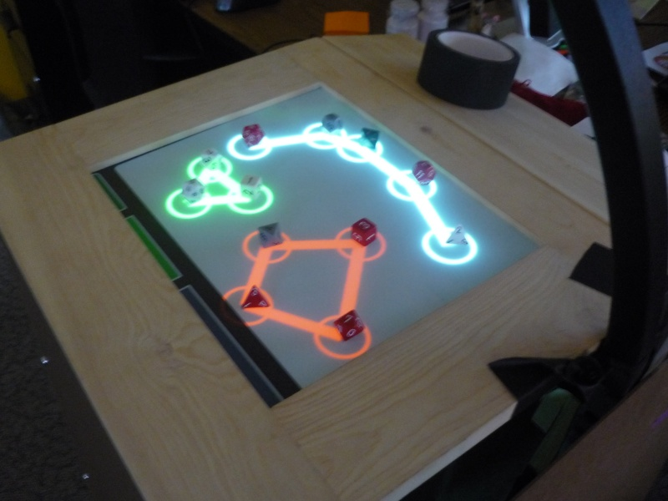
Questions to answer by playtesting (and answers discovered after playtesting):
- If the "close enough" distance for connecting dice too low, too high, or right on?
  - Still seems about right.
- Is the number of dice given to the player at the beginning too few, too many, or right on?
  - (Objective 1) Probably too few. So few dice tends to make the player want to create one big shape.
  - (Objective 2) About right. The addition of opponent dice already on the board helps a lot, and there is less of a tendency to create one big shape.
- How do the different value ranges of the dice affect strategy?
  - I found myself trying to maximize my score by creating big shapes around my dice that rolled the highest.
- Do the physical properties of the dice affect strategy?
  - Not a whole lot. The smaller dice are more predictable, but the bigger dice are better at knocking other dice out of a shape.
- How does the general difficulty feel?
  - About right. Definitely not too easy, but I always felt like I had a chance of pulling a move off.
  - (Objective 2) Too easy to beat the score of the opponent dice, since they are not strategically rolled but are simply random. Difficulty varies widely depending on initial roll of opponent dice.
- Does the balance between strategy, skill, and chance feel good?
  - About right. My skills are improving and I feel that I'm better at rolling the dice to their desired positions.
- How well does Objective 1 work?
  - Not very well. It far too long to play up to challenging scores. I also tried a version where scoring really high lets you skip rounds, and that has its own problem, mainly that it loses the sense of steady advancement. In both cases, the objective of trying to get as high a score still isn't very compelling.
- How well does Objective 2 work?
  - Better than Objective 1, but fundamentally too easy. Beating the opponent dice is a more concrete objective.
What worked:
- The software bugs have been successfully fixed.
- The colored shapes really help to make closed shapes stand out and apart from each other.
- Making connected dice worth more than single dice seems to work to the extent that connecting dice, even if they aren't in a closed shape, is valued more than single dice.
- Having to roll dice on the table frame seems to work okay. It's harder to "cheat" and simply put dice where you want them. You can just have them fall off the edge of the frame onto the touch surface, but if they land too close to the edge then they may not be picked up by the software.
What didn't work (and possible solution ideas):
- Neither of the objectives worked as well as I would have liked.
  - I think the game would work a lot better with two players competing against each other. Maybe it's time to move to the two-player variant.
- (Objective 1) Having the blank die starting on the table doesn't really add a whole lot of strategy.
- It's hard to tell how well you're doing while playing without constantly calculating your score. Calculating scores is pretty complicated and takes way too little time. It would be nicer if you could tell quickly how well you were doing.
  - Ignore numbers on the dice. (But I'd really like to be able to use that property of dice, if possible. Plus there are some strategies you get by trying to knock a die and turn it into a different number.)
  - For each shape, simply use the maximum number rolled for the whole shape.
  - Use the single highest rolled value, multiplied by its shape multiplier.
Playtest reflections:
Pretty much all of the little technical changes and rules detail changes that I made accomplished their goals. Unfortunately my biggest goal, making the objective more compelling and concrete, was mostly a failure.
Process going forward:
I think it's time to move to a multiplayer game. I think this will make the objective more concrete and compelling without making the game too easy. I will also revamp the scoring system

Two-Player Multitouch Table Dice

Third Iteration
For this iteration, I am testing two different scoring systems, each of which requires changes to various rules. Such changes that only apply to one scoring system are prepended with (Scoring 1) or (Scoring 2).
Changes to intended audience: None
Changes to materials:
- Two matching sets of dice, where each set has one of each type of die. Total dice are: 2d4, 2d6, 2d8, 2d10, 2d12, 2d20
Changes to setup:
- Do not start with any dice on the table.
- Each player starts with a matching set of dice in hand.
Changes to rules of play:
- Each player takes turns rolling dice until both players are out of dice. If (because of fouls) one player runs out of dice before the other, the other may roll his remaining dice one-at-a-time before ending the game.
- (Scoring 1) Each player's score at the end of the game is the sum of all shapes calculated like so:
  - Any single, unconnected die is worth 1.
  - A snake of connected dice is worth the maximum of all the rolled values in that line.
  - A closed shape of three dice is worth twice the maximum of all the rolled values in that shape.
  - A closed shape of four dice is worth three times the maximum of all the rolled values in that shape.
  - A closed shape of five dice is worth four times the maximum of all the rolled values in that shape.
  - And so on...
  - For any shape composed of dice from both players, only the player whose die has rolled the maximum value in that shape receives points. If there is a tie, then neither player receives points.
- (Scoring 2) Each player's score at the end of the game is the maximum of all shapes, calculated like the above method.
Changes to objective:
- Score more points that the other player.
Changes to software design:
- Fix bug occasionally allowing for more than two connections.
- Fix issue where connections can flicker on/off between dice that are almost too far apart.
- Open shapes should be colored white, closed shapes should be colored and different from each other.
Playtest:
Sun. Jan. 31, 2010, 1pm and 3pm
Walt Destler (me)
Stephen Dewhurst (1pm)
Andy Korzik (3pm)
Andrew Edwards (3pm)
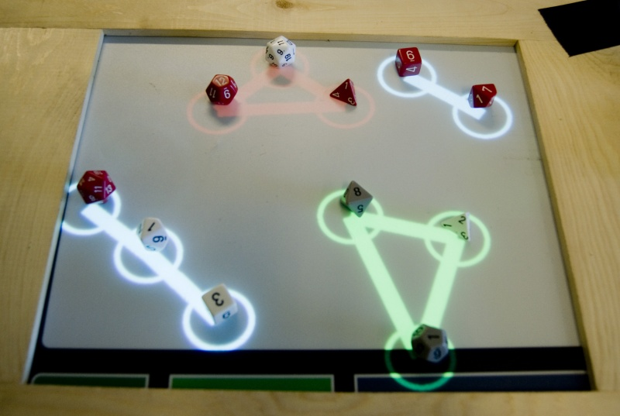
Questions to answer by playtesting (and answers discovered after playtesting):
- If the "close enough" distance for connecting dice too low, too high, or right on?
  - Stephen: About right.
- Is the number of dice given to the player at the beginning too few, too many, or right on?
  - Stephen: About right.
- How do the different value ranges of the dice affect strategy?
  - Stephen: The small dice tend to be pretty useless. It seems like everything hinges on the d20.
- Do the physical properties of the dice affect strategy?
  - Stephen: Don't think that the variable die sizes help the game.
  - Andy: Liked the strategy of multiple types of dice. The d4 is hard to knock because it won't roll, but the d20 is easy to knock because it rolls well, so you probably want to save it for last. The d20 is naturally the most fragile piece on the board.
- How does the general difficulty feel?
  - Stephen: Knocking dice is really difficult, but the gameplay really makes you need to knock dice.
- Does the balance between strategy, skill, and chance feel good?
  - Stephen: Knocking dice takes away too much from the strategy. Your strategic choices can be easily undone.
  - Andy and Andrew seemed to really like the balance being waiting toward knocking dice.
- How well does Scoring 1 work?
  - Stephen prefers this method because it feels more strategic and isn't too hard to keep track of. It's also less confusing.
- How well does Scoring 2 work?
  - Stephen doesn't like this method because it's all about the d20 and feels less strategic.
What worked:
- The core of the game -- making shapes to multiply die values -- works well and creates solid strategic objectives.
- About halfway through playtesting, we added an initial "neutral" die to the game. One player would roll the die and the other would pick evens or odds to determine who rolls first. The die is a neutral die and may be part of shapes, but must not be the maximum value or else neither player gets points from the shape. This did make the beginning of the game more interesting and varied. It really affects initial strategy depending on the value rolled.
- Andy: It's fun because you can knock them.
- Andy: It's so short that it doesn't matter a whole lot if you mess up. That makes it a fun casual game. You don't feel bad if you do bad. (That's a good thing.)
- Andy and Andrew both looked like they were having a lot of fun.
- Andy: The action is fun.
What didn't work (and possible solution ideas):
- Stephen: The weird, squished, convoluted shapes that can be made don't feel nice.
  - The software can detect angles and only create shapes with the proper angles.
- Dice that are really close together can flicker between being detected as one die and two.
  - Will fix in software.
- Positions of dice as identified by the software tend to move around a bit, sometimes resulting in glitchy behavior.
  - Will add some logic to the software that discards small movements of dice and only pays attention to large movements. Will also have the biproduct of fixing the above problem.
- For dice that are close together and detected as a single die, summing their values is too complicated/unbalancing.
  - We then tested just taking the maximum value of those dice, which works better. It also makes more sense within the game rules.
- Stephen: Circles and lines are too big -- too cluttered and hard to see.
  - Easy fix, will make smaller.
- Stephen: Too much temptation to knock dice, but doing so is too difficult and disrupts the game, but gameplay wants you to do it. Knocking dice takes away too much strategy. Aiming for a particular spot on the table is the fun part, not knocking.
  - Not sure what, if anything, to do about this. Andy and Andrew would disagree with this statement. Stephen had some ideas (detailed below) that would probably help make the game more like what he was looking for, but that would likely make fundamental changes to the game.
- Stephen: The low-sided dice seem useless.
  - As mentioned below, we tried using 6d10 instead of the varied dice, which seemed to work pretty well.
- Stephen: Wish that the game could keep track of the score.
  - Manually input values of rolled dice. This is problematic unless we use Stephen's below idea of picking the dice up after they are rolled.
- Need a way to freeze the game when it's over.
  - Will add this option.
- Andy and Andrew would both keep occluding the IR with their hands.
  - Using the surface table would fix this.
- Using a d20 as the neutral die is too hard to beat.
  - If using varied dice, switch to d12. In any case, can't use the largest die.
- The rule requiring the dice to touch the frame is hard to enforce.
  - Not sure what to do about this.
- Andrew: Table too small. Only one closed shape per game, usually.
  - Using the surface table would allow for a much bigger game.
Questions that need answering (and possible answers):
- What happens if there is a tie between the two player's maximum dice in a shape?
  - No one gets the points for that shape.
- What happens if a die skips out of the touch surface?
  - As long as the die touches or affects the software, it may not be re-rolled. Otherwise it may be re-rolled.
- Which player rolls first?
  - One player rolls the neutral die and the other player calls odds or evens.
- What if both player's dice are detected by the software as a single die? How are points awarded?
  - Points go to the player whose die rolled the higher of the two.
- Should points be cumulative or do they reset every round?
  - Winner is awarded their number of points. Loser is awarded nothing.
Other ideas from Stephen:
- Hotkey the rolled dice values.
- Use a system where dice are picked up off the table after they are done rolling. The game will remember where they are.
  - A die could replace another die if it rolls onto the other die's circle.
  - Dice should form structures, and they shouldn't fall apart or change... they can be added to.
- Use a bigger table. Surface table?
- Use 6d10 instead of one of each type.
  - We playtested this idea, and it definitely worked better than having one die of each type, but I missed having the big d20 that could swing things. So for the next iteration I may use 5d6 and 1d12 per player. (Smaller dice just to make things simpler.)
Playtest reflections:
Wow! So much good info, so much of it conflicting. Clearly this two-player version is way more fun than the one-player version, mainly because the objective is much more concrete and compelling. One's opinion of it seems to depend largely on whether you want to play an action/arcade game or a strategy game with a bit of skill. As it is currently, the game fares much better as an action/arcade game. It seems to work quite well as a fun, quick, casual game. Also, the first scoring method is the clear winner.
Process going forward:
For my next iteration I will keep with the successful arcade/action and use the first scoring method. I will also fix a number of the software and rules issues that we experienced. I will not make an attempt yet to use the Microsoft Surface table, but will keep this in mind for the future.

Fourth Iteration
Changes to intended audience: None
Changes to materials:
- Two matching sets of dice (one of each type), plus another different d12 (the "neutral" die).
Changes to setup:
- Do not start with any dice on the table.
- Each player starts with a matching set of dice in hand.
Changes to rules of play:
- To start the game, one player rolls the neutral d12 onto the table and the other calls "odds" or "evens". If the other player successfully calls odds or evens, then he go first. Otherwise, the roller of the neutral die goes first.
- Use the first scoring method from the first iteration.
- When playing in rounds, keep track of the winner's score after every round and add it to his total sum. The loser receives 0 points for that round. Play to X number of rounds, or until you get tired.
- When two or more dice are so close that they are detected as a single die, then they are treated as a single die that is worth the maximum of both dice. If the dice belong to different players, then the player whose die is the maximum receives the points for that shape, assuming that maximum value is the maximum for the whole shape. If in this case there is also a tie for maximum value, then neither player gets the points.
- If a die is rolled but does not enter the touch surface (defined as being recognized by the software or causing any effects in the game) then it may be immediately rerolled.
Changes to objective: None
Changes to software design:
- Fix issue where dice are jittery.
- Take into account angles so that weird shapes aren't made. Also maybe check for crossing connections.
- Add way to pause game.
- Make circles and lines smaller.
Playtest:
Tue. Feb. 2, 2010, 11:30am (in-class)
Walt Destler (me)
Freddie Sulit
Mike Capristo
Jesse Schell
Questions to answer by playtesting (and answers discovered after playtesting):
Most of the questions from the previous three iterations have been answered to my satisfaction, so I won't bother repeating them here.
- Does using a d12 instead of a d20 work better?
  - Yes, it seemed to work better. No matter what the d12 rolls, you still have the option of using the d20 to try to beat it.
- Does the new shape angle logic make the game more fun, less confusing, and more strategic?
  - Too soon to tell yet. Sometimes people seemed a little confused by how/when dice are connected, but once it was explained, people seemed satisfied with the explanation.
What worked:
- People were really intrigued by the novel use of technology.
- People were intrigued the potential of using dice with the combination of multitouch technology.
- People generally liked the combination of skill and strategy, even if the balance between them wasn't perfect.
What didn't work (and possible solution ideas):
- Jesse: Scoring is a headache. (And I agree.)
  - Jesse's scoring ideas:
    - Keep a little whiteboard around the table to help keep track.
    - Different shapes are worth different amounts, regardless of the die values. The player with the highest sum owns that shape.
    - Use Bocce scoring as inspiration.
- Jesse: Too many different kinds of dice.
- Difficult to tell when dice will connect.
  - Add circles around dice.
- Rolling dice off frame of table is tricky, maybe a little too so.
  - One of my ideas I've been toying with is constructing a small trough that the players would roll dice down. This would make rolling dice easier, and may add some strategy, making the die shapes more meaningful.
- People still seem to want a bigger table.
Other ideas:
- Jesse: Called the shapes "constellations"... could be a useful metaphor / theming for the whole game.
- Add numerical indicators to display worth of shapes.
Playtest reflections:
Got some really good feedback, especially from Jesse, during today's in-class playtest. I think that Jesse's absolutely right about making the scoring simpler.
Process going forward:
Aside from making the scoring rules simpler, I will also investigate using the Microsoft Surface table so that I have a bigger surface area.. This is a big technological question mark. I will also try making a little trough to roll dice down. I think that might be a more fun way to play, but I'm not sure yet without trying it.

Star Dice

Fifth Iteration
Changes to intended audience:
- Should appeal to fans of Star Trek, as well as possibly astronomy and space nerds.
Changes to materials:
- An additional "neutral" d20. (Added in partway through 4th iteration playtesting.)
  - Given the change in the scoring system, the neutral d20 should now be much easier to defeat.
- At least one (optimally 2) wooden trough, about 6" long that dice can be rolled down. This is called the "star shooter".
- One Microsoft Surface table.
Changes to setup:
- Do not start with any dice on the table.
- Each player starts with a matching set of dice in hand.'
Changes to theming:
- The game is now called "Star Dice", and is themed to look like Star Trek.
- One player is the Federation and the other is the Klingon Empire. The neutral die is the Borg.
- The shapes made by the dice are now called "constellations".
Changes to rules of play:
- Each player receives a set number of points for each constellation he controls. To control a constellation, the sum total of the player's rolled die values in that constellation must exceed the sum total of the other player, as well as exceed the value of the neutral die if the neutral die is also in the constellation. If the sum totals are tied, then neither player receives any points from that constellation. Points for constellations are awarded like so:
  - A single, unconnected die is worth 0 points.
  - A string of dice, no matter how long, is worth 1 point.
  - A 3-sided constellation is worth 3 points.
  - A 4-sided constellation is worth 6 points.
  - A 5-sided constellation is worth 10 points.
  - A 6-sided constellation is worth 15 points.
  - A 7-sided constellation is worth 21 points.
  - A 8-sided constellation is worth 28 points.
  - A 9-sided constellation is worth 35 points.
  - A 10-sided constellation is worth 43 points.
  - A 11-sided constellation is worth 52 points.
  - A 12-sided constellation is worth 62 points.
  - A 13-sided constellation is worth 73 points.
- Dice are "rolled" by placing one end of the star shooter on the frame of the table, placing the die at the top of the trough, and then releasing the die. The player may hold the trough at any angle and may adjust the angle as the die descends, so long as the end of the trough stays on the frame of the table.
Changes to objective: None
Changes to software design:
- Add support for Microsoft Surface table.
- Connections between dice should not be formed until the die has stopped moving.
- Add numbers to shapes to indicate the point value of the shape.
- Show faint circles around moving dice to indicate the range at which they will connect.
- Re-theme to use stars instead of circles.
- Re-theme to display Star Dice logo when there are no stars on the table.
- Re-theme to add sound effects.
Playtest:
Sun. Feb. 7, 2010, 12:30pm
Walt Destler (me)
Since this iteration is such a huge rules and technical departure from the previous iteration, I will be testing solo so that I don't waste anyone else's time. In the next iteration I will use other players and ask them the same set of questions that I asked myself.
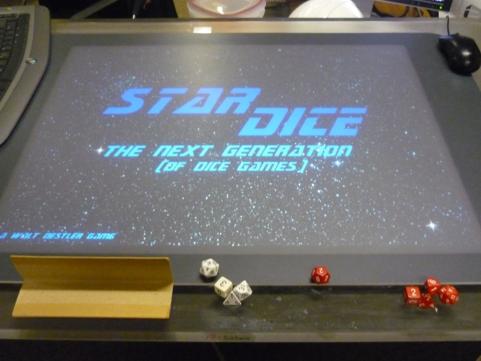
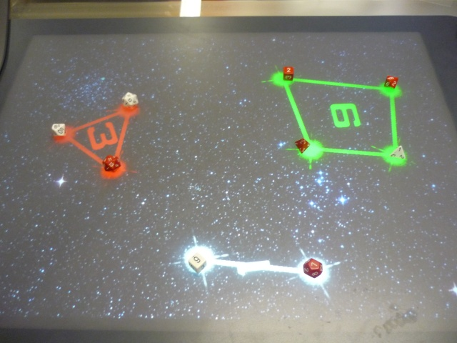
Questions to answer by playtesting (and answers discovered after playtesting):
Most of the questions from the previous three iterations have been answered to my satisfaction, so I won't bother repeating them here.
- Does using the "star shooter" make the game more fun? More skillful? More strategic? Does it prevent hand occlusions?
  - Hand occlusions are no longer a big issue with the surface table.
  - I'm not sure if the star shooter makes the game more fun. It's less playful than simply rolling the dice, but creates a more cerebral experience, which fits with the theme a little better.
  - I feel like the star shooter makes the physical properties of the dice more relevant.
- Is the new scoring system easier to keep track of? Is the game still strategic.
  - Seems easier to keep track of. Doesn't seem any less strategic.
- Do the score numbers displayed on the shapes help make scoring easier?
  - Yes, definitely.
- Does only making connection once the die has stopped moving make the game less screwy?
  - I think so, but I'm not sure.
- Do the range rings on the moving dice help to convey when dice will connect?
  - Yes.
- Do people like the Star Trek theming?
  - I like the Star Trek theming. Not sure everyone else does yet.
- Do the sound effects add valuable gameplay feedback?
  - I think it might help a little. It certainly doesn't detract. It adds to the overall "juiciness" of the game.
- How does the die connection range feel on the surface table.
  - Actually, it feels pretty good. Relative to the size of the table, it is unchanged since the kiosk version.
What worked: No additional comments not noted above.
What didn't work (and possible solution ideas):
- Angle check is confusing, even for me. The circles help to tell the distance, but you still don't know at what angle dice will connect.
Probably not worth checking. The intersection algorithm will already prevent really weird shapes. Will probably just remove this check.
- The surface table sometimes has a hard time picking up the dice. The red dice seem to work best, and the white dice work sort of as well. None of my other dice work. Since none of the other dice work, for this playtest I've had to limit the number of dice to d4, d6, d10, d12, with d12+8 as the neutral die. I will hopefully find full sets of white and red dice tomorrow.
Questions that need answering (and possible answers):
- What happens when the neutral die is rolled off the table?
  - It is re-rolled. The player calling evens/odds may re-call.
Playtest reflections:
It took a lot of technical work, but I have dice on the surface table working pretty well. Personally, I like the Star Trek theming a lot. I think the constellations work well as a metaphor for the shapes, and using Star Trek theming works with that metaphor. The new scoring system seemed to work pretty well, so I'll stick with it for now.
I'm not yet sure about the "star shooter" trough. I'll have to test with other people, including those who've played before, before I know whether I want to keep it.
The only real problems I had were the angle checks being confusing and the table not picking up certain die colors.
Process going forward:
I will remove the angle check and buy full sets of properly-colored dice. Unfortunately, I'll have to wait for tomorrow to buy the new dice, so I don't think I will have them in time for the next playtest.

Sixth Iteration
Like the 5th iteration, this iteration is using too few dice. The 7th iteration will use the number of dice for which the game was designed.
Changes to intended audience: None.
Changes to materials:
- Sets of dice need to be of colors recognizable by the surface table. Specific colors TBD.
Changes to setup: None.
Changes to theming: None.
Changes to rules of play: None.
Changes to objective: None
Changes to software design:
- Remove angle check.
Playtest:
Sun. Feb. 7, 2010, 8:30pm
Walt Destler (me)
Craig Wells (a self-described Trekkie.)
Brent Elmer
Questions to answer by playtesting (and answers discovered after playtesting):
Most of the questions from the previous three iterations have been answered to my satisfaction, so I won't bother repeating them here.
- Does using the "star shooter" make the game more fun? More skillful? More strategic?
  - Neither Brent nor Craig really liked the star shooter. It wasn't very fun, accurate, or skillful for them. They much preferred to slide the dice across the table.
- Is the new scoring system easier to keep track of? Is the game still strategic.
  - Neither Brent nor Craig seemed confused or bothered by the scoring system. It appears to be a success.
- Do the score numbers displayed on the shapes help make scoring easier?
  - Yes.
- Does only making connection once the die has stopped moving make the game less screwy?
  - Yes.
- Do the range rings on the moving dice help to convey when dice will connect?
  - Craig and Brent seemed a little perplexed over the logic determining when dice connect and disconnect, though the distance at which they connected was clear, so the rings appear to have helped.
- Do people like the Star Trek theming?
  - Both Craig and Brent, especially Craig, really liked the Star Trek theming.
- Do the sound effects add valuable gameplay feedback?
  - Yes, though they are a bit repetitive.
- How does the die connection range feel on the surface table.
  - Still seems pretty good.
What worked:
- People really liked the concept and the technology.
- Funnest part was making shapes and knocking shapes with dice.
What didn't work (and possible solution ideas):
- Brent: Too much empty space.
  - Probably a result of not enough dice in the game.
- Brent: Confused by how it behaves. Closed shapes are confusing. When does the software decide that a shape is broken?
- Brent: Feels like 3-sided shapes are stuck.
  - Make shapes auto-disconnected when they move. This will make breaking existing shapes much easier.
- Brent: Don't know how to get to high-valued shapes.
  - As above.
- Needed more dice to fill large playing area.
  - This will hopefully be resolved when I pick up more dice tomorrow morning.
- Large distance between dice made it much harder to break up shapes.
  - Adding the above auto-disconnect feature should help with this.
  - Decrease the range and increase the number of dice.
- There being no angle check does lead to some situations where dice that are essentially in a line still forming a constellation.
  - Perhaps the angle check should only be done for very small angles.
- Craig: In The Next Generation, the Klingons would not be fighting the Federation.
Ideas:
- Brent: Borg die gives a bonus.
- Brent: Dice can interrupt existing connections.
- Brent: Secondary goal of not getting wiped out by Borg.
- Craig: Slide dice instead of rolling down trough.
- Craig: Borg die is the enemy; must be defeated.
- Craig: Make all dice blank d6. (Ignore rolled values.)
- Use pool cues to push dice on table.
- Rubik's cube is the borg.
- Use black borg die that won't show on table.
  - Player can surround it with a shape to get added bonus.
- Borg die gives bonus to the shape it's in.
  - Bonus is the number on die.
- Use doubling d6 as borg die.
  - Bonus is number on die.
  - Bonus is pips on die, which goes 1, 2, 3, 4, 5, 6, instead of doubling.
Playtest reflections:
Some interesting feedback and ideas here.
First of all, the star shooter trough seems like a failure. Neither Brent nor Craig liked it much. But I'm not sure about sliding the dice. I do like the idea of using miniature pool cues to push the dice.
The Star Trek theming seems to be a success.
The constellations are definitely too hard to break and makes hitting your opponent's dice not useful enough. Making the shapes auto-disconnect should rectify this.
I'm not sure about all their ideas about sliding and the Borg.
Process going forward:
I will abandon the star shooter and instead use regular dice rolling where you have to roll on the frame of the table. Perhaps I will also experiment with using mini pool cues.
I will buy more dice so that we can play with full sets.
I will add the auto-disconnect feature described above.
Not in the next iteration, but in a later iteration, I may play with different ways to use the Borg die.

Seventh Iteration
For this iteration, I will be testing two rolling variants. The first (Rolling) uses regular die rolling on the frame of the table, and the other (Cue) uses miniature pool cues to push the dice across the table.
I am also testing two Borg die variants. The first (Borg 1) uses a doubling d6, but it gives no extra bonus. The second (Borg 2) also uses a doubling d6, but provides bonus points.
Changes to intended audience: None.
Changes to materials:
- Two sets of dice, one red , one white
- (Cue) At least one, preferably two miniature pool cues, about a foot long each.
- The Borg die is now a doubling d6 with values 2, 4, 8, 16, 32, 64.
  - (Borg 2) Each side of the Borg die should also have a number of pips on it: 1, 2, 3, 4, 5, 6, respectively.
Changes to setup: None.
Changes to theming:
- The Klingon player is now the Romulan player, since Federation vs. Klingon doesn't make sense within the fiction of The Next Generation.
Changes to rules of play:
- (Rolling) Dice are rolled onto the table. The dice must hit the frame of the table.
- (Cue) On a player's turn, he places the die anywhere on the glass frame of the table. He then takes the cue, aims, and hits the die with it.
- (Borg 2) If the Borg die is in a shape, it gives bonus points to that shape. This bonus only applies to closed shapes. The number of bonus points is equal to the number of pips face-up on the die.
Changes to objective: None
Changes to software design:
- Any dice that move are automatically disconnected from their shapes.
- Re-add angle check, but only for very small angles.
Playtest:
Mon, Feb 8, 2010, 2:30pm
Walt Destler (me)
Stephen Dewhurst
Craig Wells and Christian Tsu-Raun also watched and commented.
Questions to answer by playtesting (and answers discovered after playtesting):
Most of the questions from the previous three iterations have been answered to my satisfaction, so I won't bother repeating them here.
- How does the die connection range feel on the surface table.
  - Stephen: fine
- (Variant 1) How well does rolling dice work on the surface table? Better or worse than on the smaller kiosk? How fun is it? How skillful?
  - Stephen: Not as well as I would like. Fine except for the d4s and to some extent the d6s.
- (Variant 2) How well does using the pool cue work on the surface table? How fun is it? How skillful?
  - Stephen: I hate it. Good that it eliminates the honor system requirement. Dice are meant to be rolled.
- Which of the two variants is more fun and more skillful?
  - Stephen: Go with Variant 1, largely because I hate choosing what side to start it on, but it's largely random which side it ends up on. It's distracting to the fun part of the game.
- Does the auto-disconnect feature make shapes easier to break up? Does it make the game more fun?
  - It definitely makes the shapes easier to break up, which I think translates to making the game more fun.
- Does the second Borg variant add more strategy and direction than the first variant?
  - Yes, it definitely does.
What worked:
- Stephen: Likes the theming *a lot*. Like setting up "battle groups" and defeating the Borg.
- Stephen: Good mix of randomness and planning.
What didn't work (and possible solution ideas):
- The low values on the Borg die are too low, and the 64 is so high it can't be beaten.
  - Perhaps 8, 16, 16, 24, 24, 32
    - Stephen and I tried these new values and they seem to work well.
- Stephen: Sounds are repetitive.
  - I can find more sounds.
- Stephen: Don't like dice-knocking mechanic because there are no borders on the table.
  - Stephen: Add borders.
- Stephen: Don't like so many kinds of dice.
  - Stephen: Suggest 1d20, 2d12, 3d6.
    - I like this idea, but I don't have enough dice. Would need to get more dice.
- How shapes are formed is still a little unpredictable.
- Stephen: Romulans don't look good in red.
Questions that came up during playtesting (and answers):
- What happens if the Borg die is hit off the table?
  - The player who hit it off immediately loses the game.
- How to do odds/evens?
  - Use the number of pips on the Borg die.
- How to play a series of games?
  - In rounds, best of X.
  - Play to a score.
    - Stephen and I both like this option better since it gives more weight to huge numbers.
Ideas:
- Christian: Add torpedo dice that don't register on table.
  - Craig: Use clear stones as torpedoes.
  - You could slide torpedoes, which Craig and Christian like.
  - Walt: One torpedo per die... maybe just low-sided dice.
  - What does this do to the "constellation" metaphor.
- Add to target audience: People who already own a surface table.
Playtest reflections:
A lot of good feedback and ideas here. I feel like things are close to working really well. Clearly the pool cues were a failure, but that's fine -- I'll just stick with regular rolling.
Definitely the number of types of dice need to be reduced.
I really like the torpedo idea. That could add some good variety and strategy to the game. Doesn't really work with the "constellation" metaphor, but maybe I can call them "formations".
Process going forward:
I will attempt to acquire 1d20, 2d12, and 3d6 dice for each player.
I will however try adding torpedoes to the game.
I will re-theme to make the dice starships and shapes of dice formations. I will also add more sound effects.

Eighth Iteration
Unfortunately I was unable to find enough red and white d12 dice, so I'm making do with a slightly different set of dice: 1d20, 1d12, 1d8, and 3d6 per player.
Changes to intended audience:
- People who already own a Microsoft Surface table.
Changes to materials:
- The Borg die should have values 8, 16, 16, 24, 24, 32, with a number of pips on each side as well: 3, 4, 4, 5, 5, 6
- Six torpedo stones, preferably of colors matching the ships.
Changes to setup:
- Each player stars with three torpedoes in hand.
Changes to theming:
- I'm going to call the red player the Klingons again, despite the fact that Federation and Klingon probably wouldn't fight in the era of TNG.
Changes to rules of play:
- Having a d6 in play on the table unlocks a torpedo per one of those dice. That torpedo may then be used instead of rolling a ship onto the table.
  - Instead of rolling the torpedo, slide/flick it from the glass onto or through the table in an attempt to knock an existing die.
  - Once a torpedo is used, it may not be re-used. If it stays on the table, do not remove it from the table.
  - The number of used torpedoes may not exceed the number of d6 dice on the table.
Changes to objective:
- First player to reach 50 points wins. Each player adds his points from the round to his total.
Changes to software design:
- Take out strange number sliding. Make them fade out.
Playtest:
Tue. Feb. 9, 2010, 4:00pm
Walt Destler (me)
Andrew Edwards
Questions to answer by playtesting (and answers discovered after playtesting):
Most of the questions from the previous three iterations have been answered to my satisfaction, so I won't bother repeating them here.
- How does the addition of torpedoes affect the game? Is it more fun? More strategic? More skillful?
  - It seems to add pretty some welcome variety to the game's actions. That being said, there are some lingering issues. First of all, the torpedoes are a little hard to aim, especially at long range. Then, there's the issue that torpedoes tend to fly off the table. And lastly, torpedoes don't have any big advantages over rolling the normal dice.
- Do the low-sided dice unlocking the torpedoes make those dice more valuable?
  - Yes. I noticed myself choosing to roll the d6 dice in order to unlock a torpedo.
What worked:
- I'd say the game is all-around pretty solid. Probably not spectacular in any single area, except novelty.
What didn't work (and possible solution ideas):
- Sliding torpedoes isn't very effective. Flicking them works much better, but tends to make them shoot off the sides of the table.
Ideas:
- Allow torpedo and die to be rolled on the same turn.
  - Maybe have to fire torpedo immediately after rolling d6.
Playtest reflections:
The game is really close to being solid. The torpedoes need some tweaking. The loadout of dice is a lot better, but not optimal. I would use Stephen's suggested
loadout if I had those specific dice.
Process going forward:
I will tweak the torpedo rule so that you can only fire a torpedo immediately after rolling a d6 onto the table.

Ninth Iteration
Changes to intended audience: None
Changes to materials: None
Changes to setup: None
Changes to theming: None
Changes to rules of play:
- Torpedoes may be fired immediately after rolling a d6, and only immediately after rolling a d6.
- Torpedoes should be flicked, not slid, across the table.
Changes to objective: None
Changes to software design: None
Playtest:
Thu. Feb. 11, 2010, 9:00am
Walt Destler (me)
Craig Wells
Kim Kiser
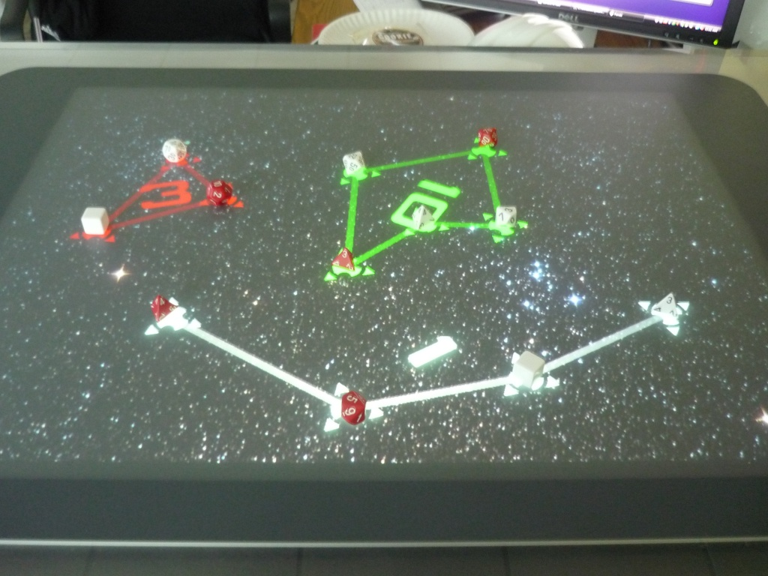
Questions to answer by playtesting (and answers discovered after playtesting):
Most of the questions from the previous three iterations have been answered to my satisfaction, so I won't bother repeating them here.
- How does the latest version of torpedoes affect the game? Is it more fun? More strategic? More skillful?
  - They really don't work very well. The torpedoes are really destructive, which reduces the strategy of trying to build shapes.
What worked:
- Seems to have a pretty good balance of luck, skill, and strategy.
What didn't work (and possible solution ideas):
- Don't like having to roll on the frame.
  - Add frame around table that marks off where you can't put your hand.
  - We tried a rule where you just have to keep your hand away from the vertical space above the table, and it seemed to work pretty well. We were a little lax about enforcing it, but no one felt cheated.
- Torpedo flicking isn't very fun or accurate.
  - Re-allow sliding.
- Feels like it needs more dice. Ends too soon.
  - We tried adding two more dice for each player, but that broke the surface table's 15 touch limit. An additional one die per player would probably help a bit.
Ideas:
- Cut torpedoes, but slide d6s.
  - We tested this, and it worked much better than the torpedoes. I'm going to stick with this rule.
- What if you can roll two at once?
- Can roll as many dice as you want. If you run out before the other player, then the other player can keep rolling.
Playtest reflections:
Ultimately, the torpedoes proved to not work. However, allowing the player to slide the d6 dice worked quite well. It made the game more varied and made the d6 dice much more useful. Adding the extra die for each player also seemed to help. Also, I think that relaxing the rule about rolling on the frame would be good -- it seemed to work pretty well in our playtest.
If I had more time to playtest, then I would try allowing the player to roll as many dice as he wishes in a turn. I may still do this as an extra-curricular test.

Cost Analysis
15 dice @ $.50 each = $7.50
Thumb drive for installation of software on surface table = $10.00 (http://www.newegg.com/Product/ProductList.aspx?Submit=ENE&N=2010170522%204024&name=%240%20-%20%2410)
Printed manual = $2.00
Baggie = $3.00
Boxed packaging = $2.00
Total cost = $24.50
Recommended sale price = $29.99
This, of course, does not include the cost of a Microsoft Surface table, which is $12,500.00. That being said, one of my target audience conditions is "people who already own a surface table."

Final Rules

Introduction
Welcome, Admiral, to Star Dice: The Next Generation (Of Dice Games)!
This is a dice game designed for owners of the antique, early-21st century Microsoft Surface table. When you are playing Star Dice, you are re-living historical battles between the Federation and the Klingon Empire!
Man the photon torpedoes, warp speed ahead!
Materials Included
- 1 Star Dice box.
- 1 printed manual. (You're reading it!)
- 1 red bag.
- 1 USB thumb drive with Star Dice software.
- 1 set of white Federation dice. (2d20, 1d12, 1d8, and 3d6)
- 1 set of red Klingon dice. (2d20, 1d12, 1d8, 3d6)
- 1 special Borg die.
- 6 photon torpedo stones.
One-Time Installation
- Start up your Microsoft Surface table if it is not already running. Wait for it to fully boot.
- Insert the included "thumb drive" into any USB port on the surface table.
- Open the thumb drive in Windows explorer.
- Double-click on Panda3d 1.7.0 to install it. Follow the on-screen instructions.
Running Star Dice
- Start up your Microsoft Surface table if it is not already running. Wait for it to fully boot.
- Start the Surface table's "Surface Input" application if it is not already running.
- Insert the included "thumb drive" into any USB port on the surface table.
- Open the thumb drive in Windows explorer.
- Double-click "SurfaceToTUIO" to run that program.
- Go into the "dice" folder and double-click "Star Dice" to start playing!

Rules of Play
Star Dice is a game for 2 players.
Setup: The two players decide who will play as the Federation (white dice) and the Klingon Empire (red dice). Each player starts with their six dice in hand, as well as three photon torpedo stones.
Battle:
- One player rolls the "Borg die" onto the table while the other player calls "odds" or "evens". Count the number of dots on the up-side of the Borg die. If the other player successfully predicted whether the number of dots is odd or even, then that player takes his turn first. Otherwise, the rolling player takes his turn first.
- Starting with the above-determined player, the two players take turns. During a turn, the player will:
  - Warp in a ship.
    - Choose any die from your hand and roll it onto the able. The player's hand must stay out of the vertical space above the touch surface of the table.
    - If the die lands close enough to other dice, the table will create a "formation" out of the dice.
    - It is perfectly acceptable to knock the other player's dice.
    - The d6 dice are special: The player warping in a d6 may choose to slide it across the table instead of rolling it. To slide the d6, place it anywhere on the glass frame and then use your hand to slide it onto the table.
- Repeat step 2 until both players are out of dice and torpedoes.
- Calculate your score:
  - For each formation identified by the table, the table will display a point value based on the size of the formation.
  - For each formation identified by the table, determine which player "owns" that formation:
    - Each player should sum the rolled die values in the formation.
    - The player with the highest total rolled die values in that formation owns the formation and receives the points for that formation.
      - If there is a tie between the players, then neither player receives any points for that formation.
    - If the Borg die is in the formation, then the winning player's total rolled die values must be greater than the rolled number on the Borg die. Otherwise, neither player receives any points for that formation.
      - If the Borg die is in a formation and the winning player has a higher total value than the Borg die then that player receives a set number of bonus points equal to the number of dots face-up on the Borg die.
War: Star Dice is intended to be played as a series of battles, each following the above rules. After each battle, each player's score is added to his total score for the whole war. The first player to exceed 50 points wins the war!
- If both players exceed 50 points after the same battle, then the player with the most points wins the war.
Other rules:
- If the Borg die is initially rolled off the table, re-roll it. The calling player may we-call odds or evens.
- When warping in a ship, if the die rolls off the table, the table never detects the die, and the die does not come in contact with any other dice, then the die may be re-rolled. Otherwise, the die may not be re-rolled.
- If a player hits the Borg die off the table then he forfeits the battle.
- If a player accidentally or purposefully touches the table such that the touch causes a change in the game's state then he forfeits the battle.
- Forfeiting the battle: The battle immediately ends and the player who forfeited receives 0 points from that battle. The other players receives points as if all the forfeiting player's dice rolled zeroes.
- If a die is not detected by the Surface table, then tough luck.
- If two dice are so close together that they are detected as a single die, then treat both dice as being part of the formation for determining who owns it, but do not re-score the formation to take the extra die into account.
- Any die hit off the table by another die or a torpedo is eliminated from the game and may not be re-rolled.
- Any die that is still on the table but on the touch surface should not be moved. It may be hit back onto the table by another die.

